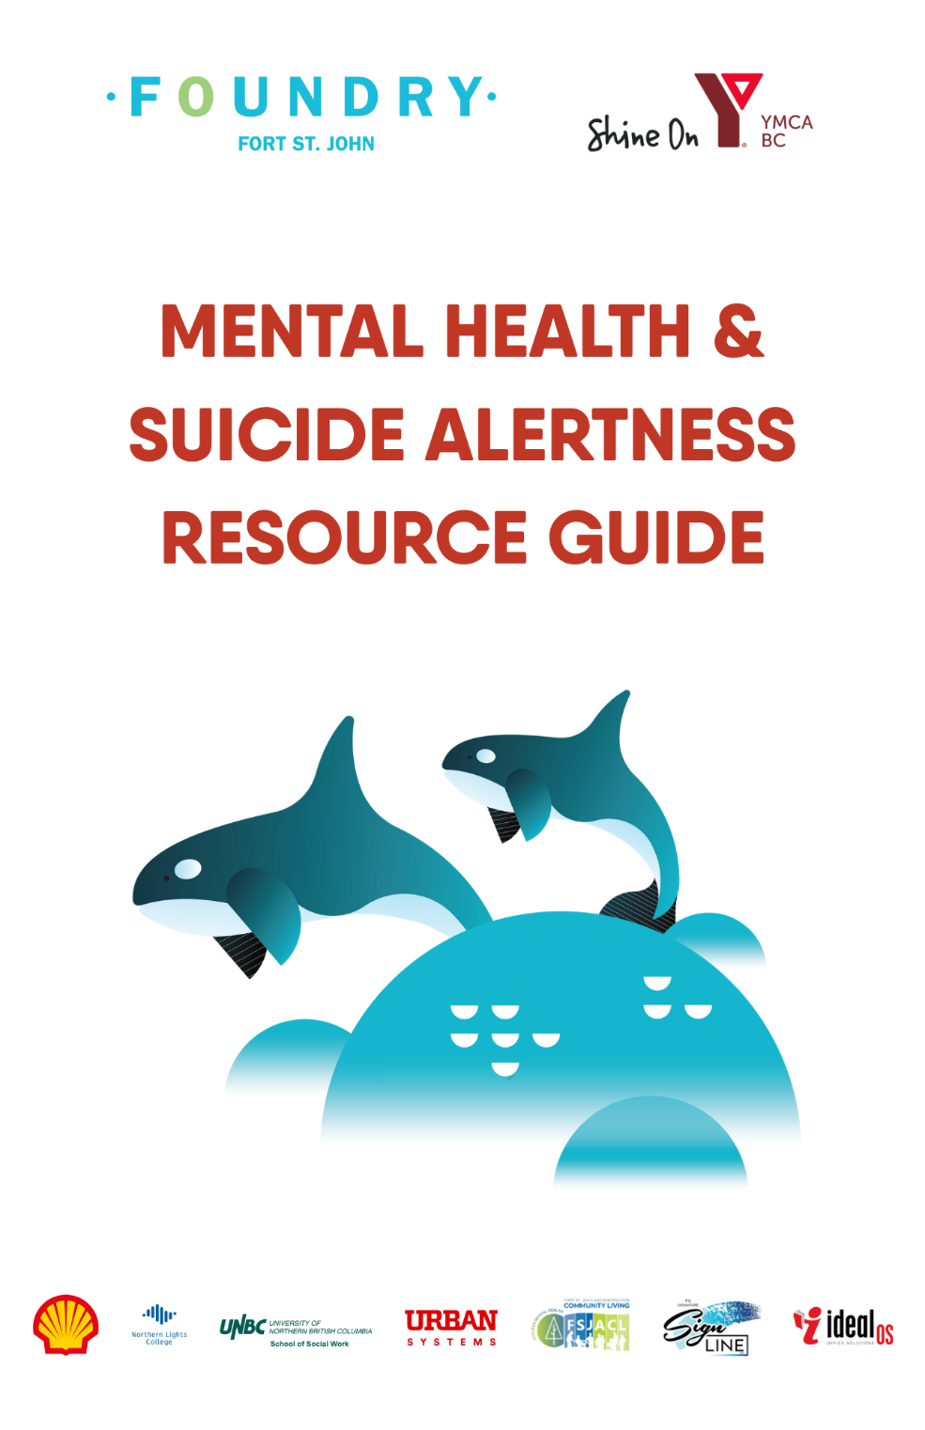

Special Thanks

A special thank you to Reilli Petersen,
member of the Foundry Fort St. John Youth Advisory Committee
and the Foundry BC Provincial Youth Advisory Committee,
for contacting every organization included in this resource guide to verify that the information is accurate, current, and up to date.

Last Updated: June 15, 2026
ALL EMERGENCIES—911

Fort St John Hospital—250.262.5200
8407 112 Ave., Fort St. John
- Emergency care with medical staff and on-call psychiatrist
- Immediate crisis care provided
- Referrals available to Dawson Creek Psychiatric Hospital, Primary Care (Mental Health and Substance Use), or Intensive Case Management services through Northern Health

24/7 MENTAL HEALTH CRISIS LINES

Suicide Crisis Help Line—988
Crisis Line—1.800.784.2433
Kids Help Phone—1.800.668.6868
KUU-US Crisis Line—1.800.588.8717
Metis Crisis Line—1.833.638.4722
Hope for Wellness Helpline (Indigenous specific)—1.855.242.3310
24/7 Mental Health Support Line—310.67.89 | 1.866.872.0113 TTY

YOUTH ACCESSIBLE RESOURCES

EMERGENCY SERVICES—911

Suicide Crisis Help Line—988
- Call or text 24/7
- Trauma-informed, culturally appropriate, judgment-free support
- Accessibility supports for deaf/hearing impaired
- Responders connected to local/national crisis services
- Talk Suicide Support Line 1-833-4566 routes you to 988

24HR BC Suicide Crisis Line—1.800.784.2433
- 24HR confidential emotional support
- Can provide emergency mental health intervention

24HR Crisis Lines of BC—1.888.562.1214
- 24HR confidential crisis prevention, intervention and information for individuals seeking support

24HR Mental Health Support Line—310.6789 (call/text)
- Barrier-free mental health support and resources

24hr National Overdose Response Service—1.888.688.6677
- 24HR confidential peer support for substance use
- Harm reduction and safety

24HR Sexual Violence Crisis Center—1.877.392.7583
- Provides confidential, immediate and ongoing support for survivors of sexual violence

24HR Youth Against Violence Line—1.800.680.4264
- 24HR line is safe and anonymous for young people to reach for support
- Non-judgemental, connection with information, resources and referrals

24HR Youth Support Line—1.888.562.8336 | Text—250.564.8336
- Confidential peer support for youth

FOUNDRY VIRTUAL—1.833.308.6379 | www.foundrybc.ca/virtual
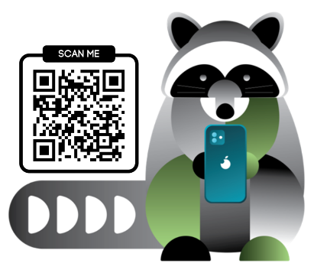

Foundry Virtual BC provides free, confidential, and accessible online health and wellness supports for youth ages 12–24 and their caregivers (anybody helping a youth navigate their journey, does not have to be blood-related) across British Columbia.

- Services offered:
  - Mental health services
  - Substance use health services
  - Physical and sexual health
  - Work, education and community services
    - Applying for work or studies
  - Trained peer support
- You only tell your story once
- Group workshops available
- Chat and text options available
- 10am-9pm Monday to Friday
- 10am-6pm Saturday and Sunday
Health Link BC—811
- Non-emergency health information and advice

Kids Help Phone—1.800.688.6868 (call/text)
- 24hr emotional support for youth
- Multilingual, culturally-appropriate

Black Youth Helpline—1.833.294.8650
- Professional and culturally-relevant youth and family assessment and intervention
- Mental health systems navigation
- Stay in school initiatives
- Education and development

Hope for Wellness Helpline—1.855.242.3310
- Available for all indigenous people across Canada
- Experienced and culturally-competent counsellors reachable via phone or online chat 24HRS
- English, French, Cree, Ojibway (Anishinaabemowin) and Inuktitut upon request

LGBT National Help Centre—1.888.843.4564
- USA-based helpline but services support to anyone who calls
- Free and confidential peer support from 2SLGBTQIA+ folks
- Mon-Fri, 11am-8pm PST | Sat 9am-2pm PST

KUU-US Crisis Line—1.800.588.8717 | Youth Line—250.723.2024
- 24HR health and wellness support
- Crisis intervention, culturally-appropriate
- Harm reduction and safety

MCFD Line for Children—310.1234 | 1.877.631.8282
- 24HR support for crime survivors
- Multilingual and confidential
Metis Crisis Line—1.833.638.4722
- 24HR health and wellness support
- Mental health, crisis intervention, harm reduction

Nasseha Mental Health Support Line—1.866.627.3342
Ontario-based mental health and community service with national reach virtually and via hotline
- culturally-sensitive, Muslim faith informed
- confidential mental health tools and support by trained Muslims with mental health backgrounds

National Youth Talkline (USA & Canada)—1.800.246.7743
- Free, confidential and safe peer support from queer-identifying and professionally-trained volunteers
- Offers support, information, and local resources
- Mon-Fri, 11am-8pm PST | Sat 9am-2pm PST

24hr National Overdose Response Service—1.888.688.6677
- 24HR confidential peer support for substance use
- Harm reduction and safety

Trans Lifeline Hotline—1.877.330.6366
Grassroots hotline and nonprofit organization for and by the trans community, operates to support both Canadians and Americans.
- 11am-7pm MST
- Mental and emotional support from trans or nonbinary peer support workers

TELUS Health Crisis Support Line—1.844.751.2133
- Confidential within the limits of the law
- Professional support for youth and families
- 16+ for individual counselling, family counselling available

OTHER YOUTH ACCESSIBLE RESOURCES

Nenan Dane Zaa Deh Zona Family Services—250.787.2151
9932-102 Ave, Fort St. John
- Counselling and cultural support for Indigenous youth and families

Saplings Mental Health Services—250.262.8842
- Supports for children and adolescents with mental health and addiction

Child and Youth Mental Health (CYMH) Clinic—250.263.0121
- Intake and referral services
- Individual and group treatment
- Mental health assessment and consultation

Breathr—kelthmentalhealth.ca/breathr
- Free app from Kelty Mental Health that suppots practicing mindfulness and skill building to reduce stress

Crisis Centre of BC—MindFip—crisis-centre-bc.thinkific.com
- Free online program for teens that provides practical and accessible knowledge and tools to support mental health and navigate life challenges
- Youth educators, parents, and teachers also welcome to access

ERASE Report It Tool—erase.go.bc.ca
- Online reporting tool and resource guide for students, adults and school staff
- Seek guidance, support and report bullying, abuse, mental health and substance abuse to your school anonymously

Family Smart—familysmart.ca
- Online resource specifically for parents and caregivers
- For caregivers whose children are experiencing mental health and substance use challenges

Indigenous Youth Wellness—www.indigenousyouthwellness.ca
- Online program and website for Indigenous youth
- Tools to learn to navigate learning about identity, culture, history and racism

MindShift CBT App—mindshiftcbt.com
- Originally created in partnership with Anxiety Canada
- App designed to empower individuals in managing anxiety through the strategies of the model of Cognitive Behavioral Therapy (CBT)
- Available via App Store and Google Play

Representative for Children and Youth—1.800.476.3933 www.rcybc.ca
- Independent provincial oversight body that uses statutory authority to advocate, review, investigate and monitor systems to improve outcomes for child, youth and family
- Individual youth and child advocacy
- Systemic advocacy
- Free and confidential

CRISIS HOTLINES

Suicide Crisis Help Line—988
- Call or text 24/7
- Trauma-informed, culturally appropriate, judgment-free support
- Accessibility supports for deaf/hearing impaired
- Responders connected to local/national crisis services
- Talk Suicide Support Line 1-833-4566 routes you to 988

24HR Crisis Line—1.800.784.2433
- 24/7 confidential support in 140 languages
- Emotional support for suicidal individuals or concerned callers
- Can coordinate emergency mental health intervention
- Referrals to local crisis centers

24HR Kids Help Phone—1.800.668.6868
- 24/7 multilingual support for youth
- Connects youth to trained professionals
- Culturally safe, tailored mental health support

24HR KUU-US Crisis Line—1.800.588.8717
- 24/7 Indigenous-focused crisis support
- Culturally safe, holistic approach
- Crisis intervention and enhanced supports

24HR Gambling Support—1.888.795.6111
- Confidential, multilingual support for gambling addiction
- 24/7 outreach, counselling, and educational info
- Culturally appropriate services for Indigenous communities

24HR Mental Health Support Line—310.6789 / 1.866.872.0113 TTY
- Toll-free, barrier-free mental health support
- Emotional support, referrals, broad mental health resources
- Interpreter services available

24HR Metis Crisis Line—1.833.638.4722
- 24/7 support for Metis individuals
- Mental health, harm reduction, risk assessment, safety monitoring
- Connects to local Metis communities and services

24HR Rape Crisis Center—1.877.392.7583
- Confidential, immediate, and ongoing support for sexualized violence survivors
- Inclusive, anti-oppressive, intersectional, feminist, decolonizing approach
- Provides information, resources, and advocacy

24HR Victim Link BC—1.800.563.0808
- 24/7 confidential, multilingual support for crime survivors and families
- Connects to housing, safety planning, counselling, and community resources

BC211—211
- Call or text 9am–9pm weekdays
- Connects to community programs and social services
- Supports include food, shelter, legal, advocacy, mental health, addictions
- Culturally safe supports for all

Child and Youth Mental Health FSJ—250.263.0121
- When put to voicemail they offer a line for child and youth emergencies at 310.1234 or 1.877.631.8282, and a line to Provincial Centralized Screening which is a part of MCFD where you can report concerns for a youth being neglected or abused.
  - The number is 1.800.663.9122

Indian Residential School Survivor Crisis Line—1.800.721.0066
- Support for survivors and families experiencing intergenerational trauma
- Trauma-informed, culturally safe, confidential care

Victim Link BC—1.800.563.0808
- 24/7 confidential, multilingual support for crime survivors and families
- Connects to housing, safety planning, counselling, and community resources

Youth Support Line—250.564.8336
- Available 4pm to 10pm
- When you reach out via text outside of their hours, it will direct you to call:
  - 1 (888) 562.1214 for immediate support
- The call number listed for the youth support line 1 (888) 564.8336 is for crisis lines of BC which will also get youth connected to support

EMERGENCY SHELTER

Meaope Transition House—250.785.5208
- 24/7 safe shelter for women and children
- Supports survivors of domestic violence through a Community Bridge Program

Salvation Army Northern Centre of Hope—250.785.0372
9824-99 Ave., Fort St. John
- Essential services for people and families experiencing homelessness
- Local emergency food and shelter
- Referrals for medical and mental health support
- Safe housing for women facing domestic violence

ALCOHOL & DRUG DETOXIFICATION

Day Treatment Program—250.263.6083
#300 9900-100 Ave., Fort St. John
- Daytime addiction support for adults in the community
- Group sessions, education, and coping skills

North Wind Wellness Centre—1.888.698.4333
- Residential addiction treatment for adults
- Counselling, cultural teachings, land-based healing

Rising Above Ministries—250.785.1008
11095-255 Road, Baldonnel
- Faith-based addiction recovery for adults
- Focus on personal healing, coping skills, life skills, and community support

Supportive Recovery Beds—250.785.0372
9824-99 Ave., Fort St. John
- Short-term, alcohol- and drug-free housing for adults in recovery
- Supports participation in recovery programs with case manager guidance

MENTAL HEALTH & ADDICTION SERVICES

Community Bridge—250.785.6021
10142-101 Ave., Fort St. John
- Free programs: counselling, family support, sexual abuse support
- Temporary shelter for women and children

Fort St. John Alcoholics Anonymous—250.794.0032
- Support for adults recovering from alcoholism
- Shares experience, strength, and hope to stay sober

Fort St. John Friendship Society—250.785.6021
10208-95 Ave., Fort St. John
- Programs for all ages promoting well-being
- Incorporates Aboriginal values and culture
- Inclusive, safe community space

Healing Hearts Support Group—250.793.8817 healingheartsfsj@gmail.com
- Bereavement support for families affected by substance use
- Peer support and advocacy

Metis Nation BC—mnbc.ca
- Advocates for Métis rights and provides culturally relevant programs
- Supports in health, education, housing, employment, and mental health

National Overdose Response Service—1.888.688.6677
- 24/7 confidential peer support for substance users
- Safety planning, harm reduction info, naloxone guidance

Nenan Dane Zaa Deh Zona Family Services—250.787.2151
9932-102 Ave, Fort St. John
- Counselling and cultural support for Indigenous people
- Group programs for youth, women, men

Peace Area Narcotics Anonymous—1.877.463.3537
- Support for adults recovering from drug addiction
- Free, welcoming meetings across the Peace region

OTHER COMMUNITY RESOURCES

Fort St. John Health Unit—250-263-6000
- Free public health and wellness services for all ages
- Immunizations, prenatal/childhood services, dental, hearing, and health education
- Nutrition info, disease prevention, environmental health, and harm reduction supplies

Mobile OPS—778-256-5483
- Mobile harm reduction program for supervised drug use
- Naloxone and overdose prevention supports
- Meets clients where they are in the community

NH Intensive Case Management—250-263-6080
- Outreach support for adults 19+ facing substance use, mental health, housing, or income challenges
- Practical help, advocacy, and coordination with services
- Connects clients to housing, healthcare, income support, and treatment options

OAT (Opioid Agonist Treatment) Clinic—250-263-6080
- Harm reduction and treatment for substance use
- Offered through Northern Health Mental Health and Addictions services

Women’s Resource Society—250-787-1121
10051 100 Ave, Fort St. John
- Supports women, children, and low-income individuals with practical help and healing-focused services
- Safe second-stage housing
- Free legal advocacy and support with housing, income assistance, and family law matters
- Drop-in center offering crisis support, referrals, education, and life skills

ADDITIONAL SUPPORTS
- Parents/family members who can help increase safety
- The ASK Workshop trained community member
- ASIST trained community members
- Mental Heal First Aid trained community members
- Elder
- Social Worker
- Trusted Friend
- Sports Coach
- Extra curricular activity leader
- Big Brother/Big Sister mentor

