**Foundry GAIN SS Online Training Quizz & Scoring Sheet**

**Question 1:** Which of the following best describes the structure of the GAIN family of instruments?

Select one:

a. High-structured

b. Low-structure

c.  No structure

d. Medium-structured or semistructured

**Question 2:** The chief aim of the GAIN Short Screener is to _______________.

Select one:

a. Identify clients in need of further assessment or services

b. Provide a clinical diagnosis

c. Determine the appropriate level of care for the client

d. Calculate the cost to society of each client

**Question 3:** Which of the following is a benefit of using a screener?

Select one:

a. Screeners help to identify those in need of further assessment.

b. Screening helps to identify co-occurring problems so that each can be addressed.

c. Completing screeners allows clinical staff to focus on clients who have been identified as needing services

d. All of those listed are benefits.

**Question 4:** The GAIN-SS is made up of four sub-screeners. Which of the following is **NOT** one of them?

Select one:

a. Internalizing Disorder Screener

b. Vocational/Environmental Screener

c. Crime/Violence Screener

d. Externalizing Disorder Screener

**Question 5:** If you are using the GAIN-SS to screen for current disorders, which symptom count in the staff use only scoring box should you focus on?

Select one:

a. Past month

b. Ever

c. Past 90 days

d. Past year

**Question 6:** A score of ___ or above is considered a high score for the Total Score or a Domain Score.

Select one:

a. 10

b. 5

c. 2

d. 3

**Question 7:** A high score on the Total Disorder Screener indicates that:

Select one:

a. The client is likely to have a diagnosis.

b. The screener was not appropriately administered.

c. The client will need residential treatment.

d. The screener should be repeated.

**Question 8:** Moderate or high scores on any of the four domains in the GAIN-SS show:

Select one:

a. Which areas the client may need specific behavioral health services in.

b. What specific diagnoses the client has.

c. How long the screener took to complete.

d. How long the client’s past treatment episodes lasted.

**Question 9:** Which symptom count is recommended to be used as a simple measure of change?

Select one:

a. Ever

b. Past Month

c. Past 90 days

d. Past year

**Question 10:** Someone needing mental health treatment related to attention deficits, hyperactivity, impulsivity, conduct problems, or gambling would likely have a moderate or high score on which screener?

Select one:

a. Internalizing Disorder Screener

b. Substance Disorder Screener

c. Externalizing Disorder Screener

d. Crime/Violence Screener

**Question 11:** What is the below client’s past year score on the IDScr?

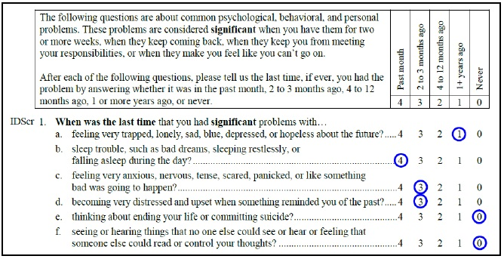

Select one:

a. 10

b. 1

c. 3

d. 6

**Scoring Sheet:**

|  |  |
| --- | --- |
| Item # | Correct Answer |
| 1 | d. Medium-structured or semistructured |
| 2 | a. Identify clients in need of further assessment or services |
| 3 | d. All of those listed are benefits. |
| 4 | b. Vocational/Environmental Screener |
| 5 | d. Past year |
| 6 | d. 3 |
| 7 | a. The client is likely to have a diagnosis. |
| 8 | a. Which areas the client may need specific behavioral health services in. |
| 9 | b. Past Month |
| 10 | c. Externalizing Disorder Screener |
| 11 | c. 3 |